CHAPTER 1

Introduction

* 1. Background

Public Transport is one of the leading solutions taken up in the current scenario where all the leading countries are stressing upon Sustainable development. However, whenever we use Public Transport Service, we face an issue, due to the rush and the prolonged waiting time. Thus, promotes people to move towards use of private vehicles and leads to increase in pollution related problem. This project aims to address this issue, we intend to display the capacity and the Estimated arrival time of the buses on Screens provided at Bus Stop. This will help make commuters travel easier and hassle free.

* 1. Relevance

The current technological development seen in the Electronics and Telecommunication stream is quite evident and has a very prominent use in solving some of the many daily problems that we have. The Public Transport is one such sector where we have proposed to use GSM and GPS modules to communicate between bus and bus stops, to make the Public Transport efficient and easier for general common public.

* 1. Literature Survey

1.3.1 Previous approach to the problem and its drawbacks

The research for developing a Smart Public Transport System has been going on since long time. The System developed until now have a fixed time schedule of buses set that predicts arrival of buses on the basis of this fixed schedule, however it has been observed that there has been a major change in the percentage of breakdown that occurs in this public system has increased. Thus, our reliance on this system is questionable. Hence efforts are being put in to develop a new system for the same.

1.3.2 Recent innovation

The IEEE paper (written by authors Rose Mary John; Finky Francis; Joe Neelankavil; Alwyn Antony; Ancy Devassy; K.J. Jinesh) states the use of GSM and GPS for the bus. We propose to further develop this system by integrating the extra capacity feature to be transmitted over the GSM used.

* 1. Motivation

The technologies currently deployed as a solution to make public transport efficient have had a very good effect on solving the problem. However, these systems/applications have a tendency to crash in the case of breakdown of buses, network issue etc. The project we are working on currently looks to solve this problem and prove to be more efficient in conditions of breakdown. Furthermore, it addresses the problem of congestion and helps distribute the rush uniformly among a wide stratum.

The system also proposes an idea of designing a network for the public sector that can help promote their use by addressing some of the general issues faced by people. This increase in usage will also help generate a better revenue which can be further streamlined for addressing other issues.

* 1. Aim of the Project

Design and develop an efficient public transport system.

* 1. Scope and Objectives

The prime objective of this project is the enhancement in Public Transport System. This is to be done by increasing the comfort level for commuters and developing a system that is efficiently accountable and helps track buses and therefore makes Public Transport efficient and increases its use amongst masses.

Objectives:

* **Learn existing system being used locally, and globally.**
* **Design and develop new system with improvement.**
* **Experiment and test developed unit.**
  1. Technical Approach

We have integrated the GSM and GPS module and interfaced it with the ticket machine used for lending tickets in the bus. This helps us to track the real time location of the bus and the number of vacant seats in the bus. The GSM module transmits the capacity registered via ticket machine to the receiving module located at bus stops along the routes. The microcontroller at bus stop end calculates the time required for the bus, using the real-time coordinates of bus and the fixed coordinates of bus stop. The microcontroller than displays this time and the capacity on the LCD screen at respective bus stops.

CHAPTER 2

Design of the System

2.1 Block Schematic

Designing any system, it is required to decide different functional block that makes it. In this project different such as GSM, Switches, Arduino.

* We intend to integrate GPS module and a different circuitry (to count the capacity) to a microcontroller and Transmit the same wirelessly to the corresponding Bus Route Stops.
* This info will be Displayed on an LCD display and hence will help Commuters to board and make their travel hassle free.

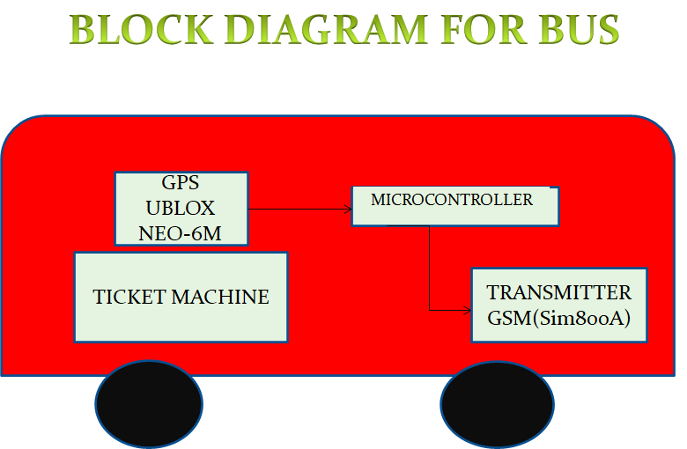

Figure 2.1: Block Diagram of Bus consisting of all components that would be there inside the ticket machine

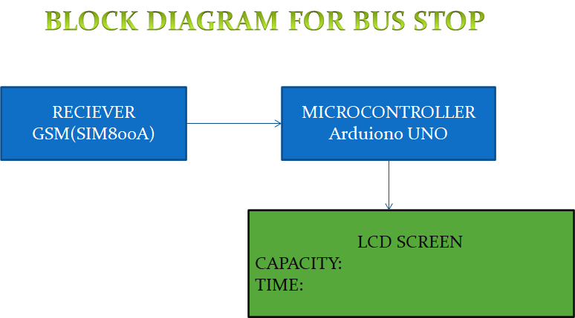

Figure 2.2: Block Diagram of the circuitry to be deployed at bus stops

2.1.2 Arduino

Arduino Uno is a microcontroller board based on the ATmega328P. It has 14 digital input/output pins (of which 6 can be used as PWM outputs), 6 analog inputs, a 16 MHz quartz crystal, a USB connection, a power jack, an ICSP header and a reset button.

2.1.3 GSM & GPS

**SIM 800A GSM/GPRS Modem** works on frequencies 850/900/1800/1900MHz. The baud rate is configurable from 9600 through AT command. The GSM/GPRS modem is having internal TCP/IP stack to enable you to connect with internet via GPRS.

SIM 800A GSM/GPRS Modem suitable for SMS, Voice as well as DATA transfer applicable. The power supply allows you to connect wide range unregulated power supply. Using this modem, you can make audio calls, SMS, Read SMS, attend the incoming calls, and internet through simple AT commands. We have preferred GSM module because of the wide range of network that can be developed.

We have also used the NEO-6 GPS module which is an accurate, fast and cost-effective module that can help trace the location and gives us the accurate location. The NEO-6 module series is a family of stand-alone GPS receivers, that work on the u-blox 6 positioning engine. These provide flexible and cost-effective receivers offer numerous connectivity options in a miniature 16 x 12.2 x 2.4 mm package.

2.1.3 Ticket Machine

Ticket machine contains switches which then connect to GSM to send to bus stop. It contains information like number of passengers, time of arrival this calculated from formula given.

2.1.4 LCD Screen

The LCD which located at respective bus stop is of 16 x 2 display, receive information from GSM & GPS as number of people in a bus, time of arrival respectively.

* 1. Equations: -

We use the Haversine Formula to measure the distance between coordinates, this formula uses the real time coordinates we acquired from the GSM of the bus and the ones that we get from the GPS located at bus stop, this formula uses the latitude( φ) and longitude(λ),the mean Radius of earth(R) as:-

**Haversine Formula: -**

|  |
| --- |
| a = sin²(Δφ/2) + cos φ1 ⋅ cos φ2 ⋅ sin²(Δλ/2) |
| c = 2 ⋅ atan2( √a, √(1−a) ) |
| d = R ⋅ c |

(2.1)

CHAPTER 3

Implementation, Testing and Debugging

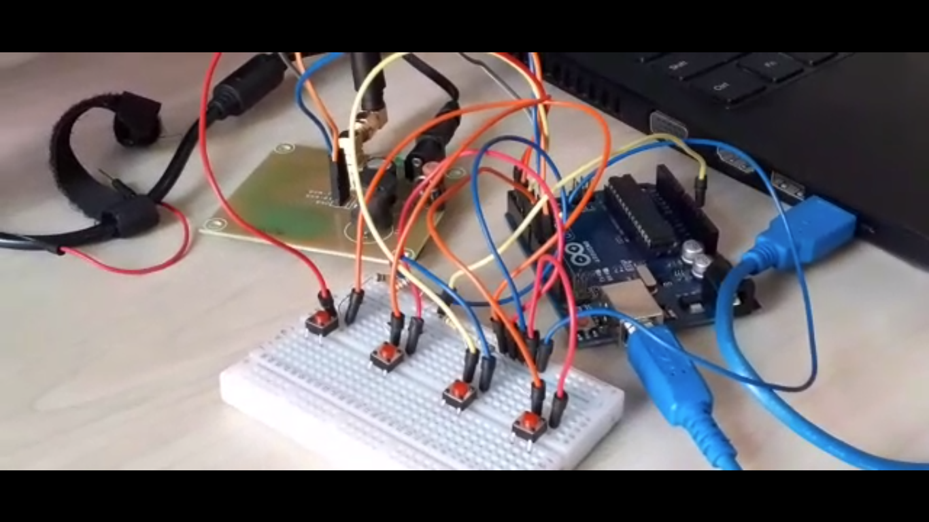

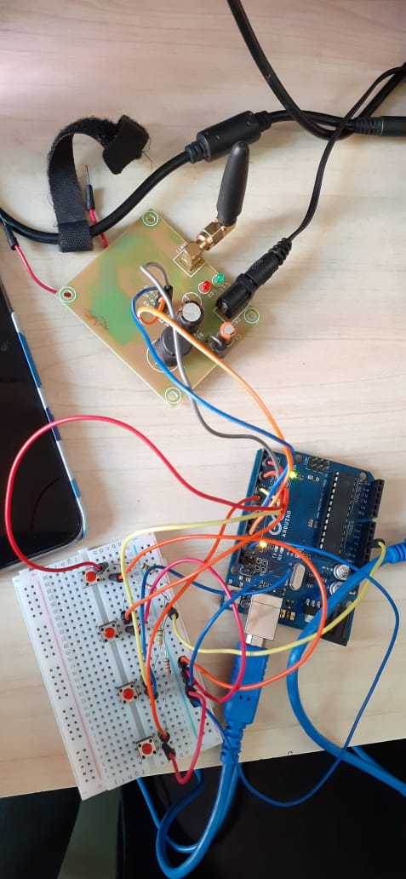 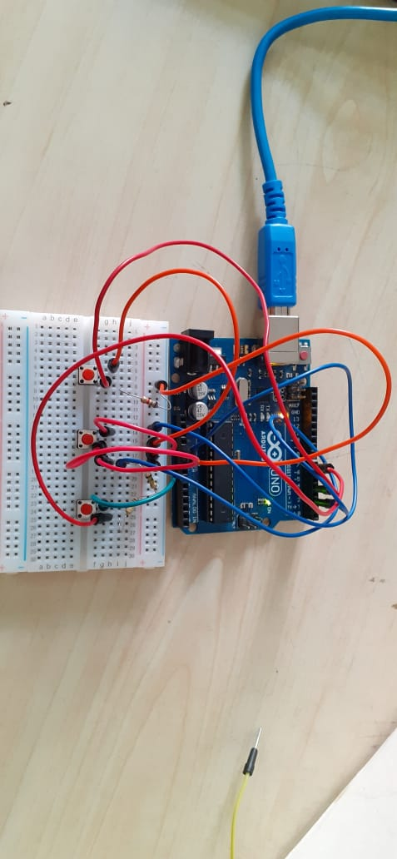

Figure 3.1 (a), (b): Interfacing of GSM and Ticket machine with GSM;(c) Ticket Machine circuit testing.

CHAPTER 4

Results and Discussion

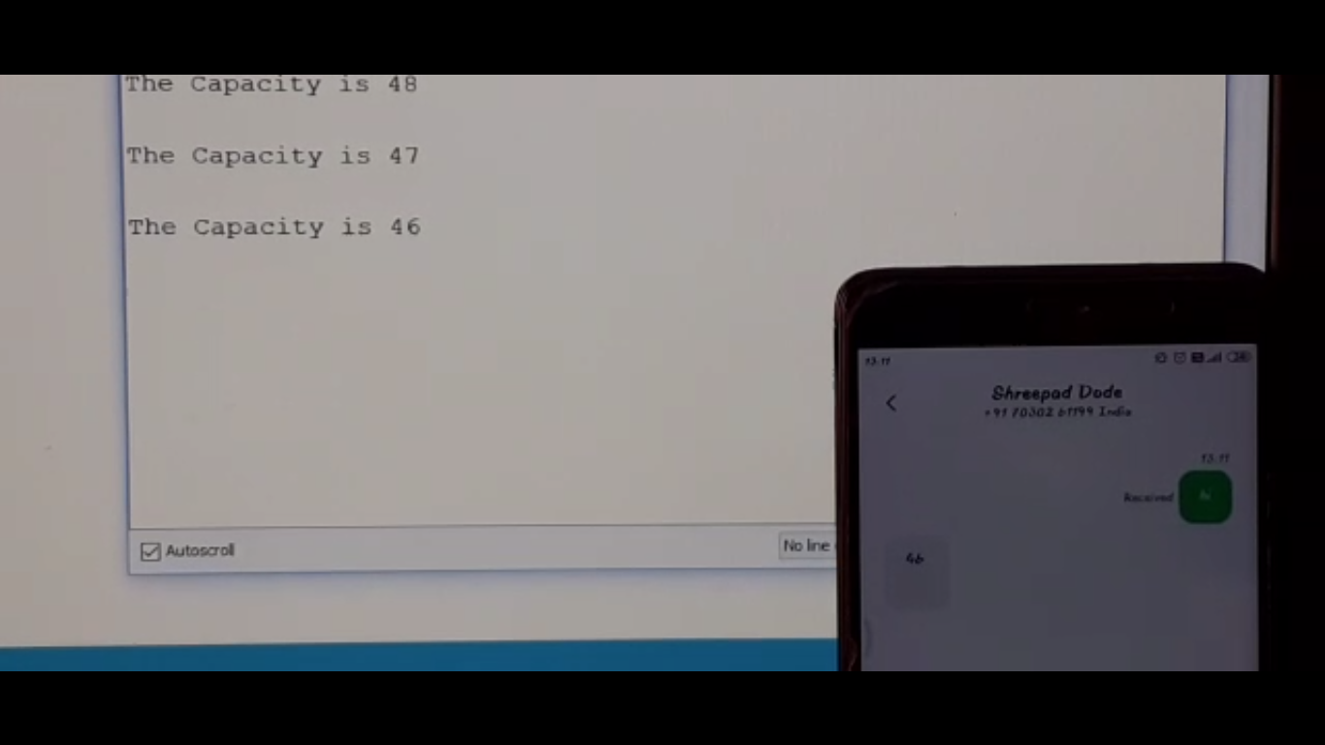

Figure 4.2: Transmitting Capacity from Ticket machine circuit to mobile during test run.

All the graphs should be clearly visible with title, labels of each axis, legends, and line markers as shown in Fig. 2.2 above. Graphs, results must be clearly interpreted in the text by explaining the numerical, its significance and inferences as followed. BER performance of the basic linear array of isotropic elements is carried out for various SNR and plotted in Fig. 2.2. Here, the algorithmic parameter *µ* is set to 0.06 and the initial weight vector to [0.1+0*i* 0.1+0*i*]. MBER solution converged to a lesser BER after 15 iterations that compared with MMSE solution. At SNR=15, the BER is found to be 10-7.662 and the weight vector to be [0.0228+0.0056*i* 0.0197+0.0127*i*] by MMSE approach, whereas, by MBER approach, BER is 10-9.907 and weight vector is [0.48000.7456+0.4623*i*].

Conclusions

We have successfully developed system using GSM modules and developing ticket machine for the same. We learnt the interfacing of various components like GSM and push buttons to Arduino and also successfully used this to transmit and receive messages generated by the ticket machine.

Future Scope

The Smart Public Transport System developed under this project can further be further integrated with some daily use apps like Google Maps and official Bus transport Apps.So as to make this system accessible to people even at their convenience.

The System can also be converted into a mobile application which will further integrate the facilities to book tickets, apply for daily pass etc. This would help users to plan their trips well before time and also help the daily commuters to keep a track of the bus they require to abode.

References

1. Rose Mary John; Finky Francis; Joe Neelankavil; Alwyn Antony; Ancy Devassy; K. J. Jinesh; “Smart Public Transport” Proc. 2014 International Conference on Embedded Systems (ICES)
2. GSM connection with Arduino and using GSM to send and receive SMS-https://maker.pro/Arduino
3. GPS basics and interfacing with Arduino-https://www.electronicwings.com/
4. Datasheets-https://www.ublox.com/sites/default/files/products/documents/NEO-6_DataSheet_%28GPS.G6-HW-09005%29.pdf; https://simcom.ee/documents/SIM800A/SIM800A_Hardware%20Design_V1.02.pdf
5. Haversine formula-https://rosettacode.org/; https://www.geeksforgeeks.org/haversine-formula
6. Tutorials for interfacing of components using https://www.arduino.cc; https://www.instructables.com